**Critical Player Report - *Hearthstone***

**Composer: Gordon (Cunbo Li)**

**Email:** [**gordon.lee@nyu.edu**](mailto:gordon.lee@nyu.edu) **or** [**cl3846@nyu.edu**](mailto:cl3846@nyu.edu)

*Hearthstone* is a popular modern card game that widely played around the world. The key factors that make this game so success is aesthetic design, the mechanic of attacking and strategy, and the culture of *World of Warcraft*.

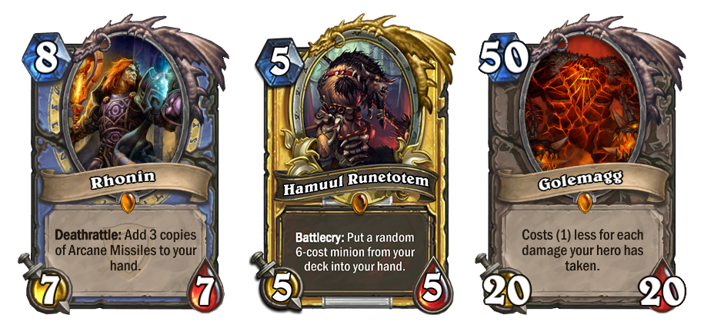

*Hearthstone* is a digital online game, but it has feeling like the player is playing a physical card game face to face on a game board. To be more specific, *Hearthstone* has a realistic the UI (User Interface) design, various 3D animations for cards actions and drag & drop interaction to playing a card. The entire game looks so beautiful, fantastic and every factor was well designed. Each card has a sophisticated design (showing in Figure01). This not only reflected the design style of Blizzard but also gave the player the same feeling of playing the *World of Warcraft*. Cards were distributed to players in each turn. The player has to drag a card to the field or drag a card on the field to do some action. In the game, there are a lot of animations that looks so amazing and realistic. For example, distributed cards will flip over to players. Attacking action has dust, flame or flash that splashing out, and also a shaking to the whole game interface. With these detail animation, everything in the game is alive. If the player will attack to the opponent or opponent’s minion. The player should drag and drop the selected card onto the destination for the desired action. Figure02 is showing the drag and drop interaction in the game. With this kind of action, the player will have a feeling like playing a real card game.

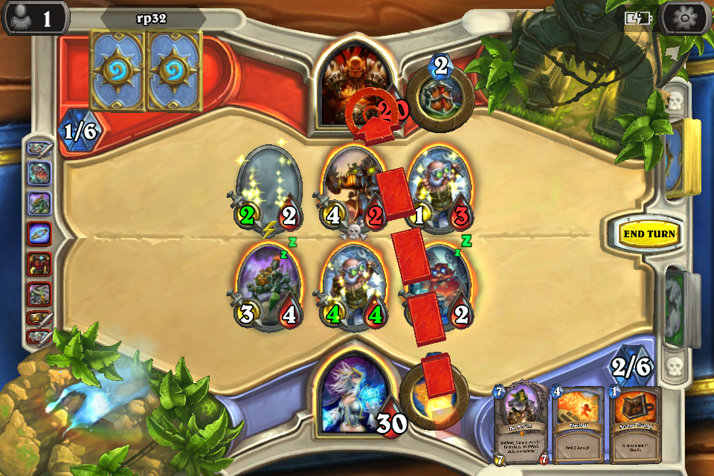

Figure02

Figure01

Besides the aesthetic design in the game, the mechanic of attacking and strategy is also very important to the success of *Hearthstone*. *Hearthstone* was designed based on *World of Warcraft*. The attacking action is a key part to the gameplay. The player will have the same feeling of playing *World of Warcraft* while they playing *Hearthstone*. The attacking mechanics is actually comparing attacking number in the game. This mechanics is also same as most of the card game in the real world. So *Hearthstone* is a combination of a physical card game and video game. Or we can say *Hearthstone* is a simulation of physical card game with the culture of World of Warcraft. In the game, there is a lot of strategies. For example, the player can use Taunt Minion Card to protect the Hero, because the opponent has to kill all the Taunt Minions before any action to the Hero. The player can also use magic cards to increase “Health” or blind the opponent’s cards. The player also needs to well plan the cards order because most of the cards cannot immediately do an action when they were just distributed to the field. So that strategy in the game is a very important mechanics to the game, and also a key factor to all kind of card game.

Based on the discussion above, I believe that Hearthstone is a successful modern card game because of its aesthetic design, mechanics of attacking and strategy, and also the background culture of *World of Warcraft*. All these factors give the player a feeling of playing a real card game on digital devices.